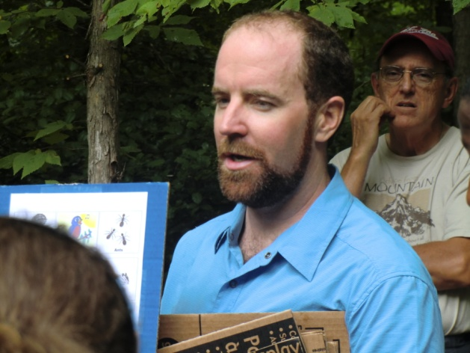 | Ross Andrews Nature Poetry Contest 2015  Sponsored by  The Center for Human-Earth Restoration
Ross Andrews was a young environmental educator who believed in the importance of the Natural World and the human’s relationship to it. He spent years developing his own deeper relationship to Earth. Even as a soil and forestry restoration scientist, Ross knew that the key to our collective futures was through the heart and spirit. He found that poetry was the path to express his passion for the beauty, wonder, awe and/or intimacy that one experiences with the natural world. In 2014 his friends began this poetry contest to honor Ross and his work.
The contest will have four categories: grades K-5, 6-8, 9-12, and adult with monetary awards for two winners in each category. Entrants must follow these rules:
- Name your poem form for example: Sonnet, haiku, villanelle, free verse, etc.
- Use basic rules of capitalization
- Proof read for grammar and spelling
- No inappropriate or vulgar language will be accepted
- Use formal English- no abbreviations
- Only non-published poems will be accepted
- In a cover letter include your name, address, phone number, email address, grade, age, school, city, county, state a brief descriptive paragraph of time and location of poetic theme, and certify that the poem entry is your original work.
Reading and judging will be conducted by panel of High School English teachers from several different school districts. Winners will be notified prior to Earth Day, April 22, 2015. Winners will be asked to read their poems during an Earth Day Celebration on Friday, April 24, 2015at which time they will receive their award.
Deadline:
If emailed, no later than midnight, March 31, 2015. Send to humanearthrestoration@gmail.com If mailed, entry must be postmarked no later than March 31. Send to:
Ross Andrews Nature Poetry Contest
Center for Human-Earth Restoration
6814 Fayetteville Road
Raleigh, NC 27603

